Dear Representative/Senator,

My name is Bill Lynn. I’m the founder of the ethics think tank PAN Works, a research scientist at Clark University, and a teaching professor at Canisius University. I specialize in ethics and public policy with a focus on animal studies and sustainability studies. I have extensive experience with barred owl management, wolf recovery, and outdoor cats and biodiversity.

In particular, I am intimately familiar with the barred owl and spotted owl debate. I was the ethicist hired by the US Fish and Wildlife Service (FWS) to help design, train, and facilitate the discussions of the Barred Owl Stakeholder Group (BOSG). I’ve also written peer-reviewed articles on the killing of barred owls for the benefit of spotted ones.

The BOSG was part of the scoping process for the northern spotted owl recovery plan. I helped teach and convene its discussions of the ethical and scientific arguments around the experimental removal of barred owls. This field experiment preceded the current plan to kill approximately half a million barred owls.

In other letters, you will read good scientific and economic reasons to object to the FWS’s current plans and avoid what amounts to a massacre of barred owls. The reasoning is compelling.

- Competition Between Species. Barred owls are and will continue to push out spotted owls through competition with barred owls.
- Vacuum Effect. When barred owls holding territory are shot, other barred owls quickly re-inhabit those territories. Lethal removal speeds up this process, something colloquially known as the ‘vacuum effect.’
- Expense. The killing of so many barred owls will be expensive. These are not easy kills and require skilled shooters. Moreover, barred owls will teach their young to avoid humans, making the quota for dead barred owls more costly over time.
- Effectiveness. It is simply not possible to remove barred owls from the vast and unrestricted spaces of the Pacific Northwest.
- Eternal Massacre. The killing of barred owls will therefore not solve the slow extinction of northern spotted owls. Rather, the plan envisions massacres of barred owls with no end in sight, and for no other reason than the misplaced hope that something will change.

To these reasons, I want to add further considerations grounded in the ethics that underwrote the work of the BOSG and the original removal experiment.

Politics is Ethics Writ Large. As policymakers, you already know that “politics is ethics writ large” (Aristotle). Policy both reflects and institutionalizes our values, for good or ill. You also know that all policy debates are driven by values, particularly moral values. We may speak as if policy is simply about facts and cost/benefit calculations, but that is a facade. Policy is a wicked problem where often incompatible values held by different groups are in conflict. Science and ethics play a complementary role in leading us out of these wicked problems. Science helps keep our facts transparent and accountable. Ethics does the same for our values. Together, they help us triangulate on better vs. worse policies.

Ethical Foundation of the Removal Experiment. The experimental removal plan was never a pilot project for the current policy of massacre. Rather, it was meant to ascertain through a field study whether the killing of barred owls would allow spotted owls to establish their own refugia — habitats they could hold on their own in order to thrive in the wild. This was the practical scientific question we had in mind.

Yet this scientific question was itself motivated by a deeper ethical concern. Both owls are valuable, in and of themselves as well as to the forests of which they are a part. How then do we do right by the spotted owl without doing wrong by the barred owl?

After all, people are undoubtedly responsible for the endangerment of the northern spotted owl. Whether barred owl migration from east to west was aided or delayed by human landscape change (there are arguments for both explanations), it is not the barred owls’ fault that spotted owls are in trouble. The prospect of extinction was caused by clear-cutting old-growth forests. The barred owls simply came along at a bad time.

In addition, the BOSG explored a variety of nonlethal ways to manage barred owls — oiling eggs to prevent hatching, translocating owls elsewhere, hazing owls already in place. None of these methods was feasible.

Harm-Benefit Ratios. With the fate of spotted owls in the wild at stake, the BOSG reasoned that a small, time-limited killing of barred owls was justified if it could establish that spotted owls could thrive in their own refugia. To make this ethical trade-off, we used harm-benefit ratios. These are commonly used in bioethics and are similar to the policy practice of balancing individual rights with the common good. Because the harm to barred owls was contained, the harm-benefit ratios of the removal experiment were arguably reasonable. Unfortunately, the removal experiment failed. While it paused or slowed the decline of spotted owls in some areas, it did not result in them establishing refugia in any area.

Harm-Benefit Ratios in Reverse. Now, under the current plan, the harm-benefit ratios are reversed. Barred owls will experience tremendous loss of life indefinitely, but this will do nothing to stop the decline of the spotted owl. This is especially true in light of ongoing climate change, catastrophic fires, habitat degradation, agroforestry, land conversion, and a hostile policy environment (e.g., loss of roadless and critical habitat designations). A plan to kill barred owls in huge numbers, ad infinitum, is not simply too expensive and unworkable; it is immoral. The harm cannot be justified by the benefits, even if we balance the loss of barred owls’ lives against the extinction of the spotted owls in the wild.

Allow me to conclude by saying that to care about both barred and northern spotted owls is to be faced with a Sophie’s choice – making a harrowing decision about which owls should survive in the wild or at all. The barred owl removal experiment has failed its original purpose to demonstrate that spotted owls can establish refugia. Vastly expanding the killing of barred owls into perpetuity is scientifically ineffective and ethically wrong.

The ethical path forward is not “doing something” no matter its ineffectiveness. It is facing up to our collective failure in this instance, doing more to prevent human-generated extinction in the future, and making space for wild lives to thrive. Making policy is often knowing how and when to intervene. Yet it is also knowing when not to intervene. We are in such a position today with respect to barred and spotted owls.

See:

Lynn, W. S. (2018). Bringing Ethics to Wild Lives: Shaping Public Policy for Barred and Northern Spotted Owl. Society & Animals: Special Issue on Wildlife, 26(2), 217–238. https://doi.org/10.1163/15685306-12341505

Lynn, W. S. (2025). Killing barred owls to save spotted owls is a moral atrocity. The Ecological Citizen., 8(2), epub–136. https://www.ecologicalcitizen.net/pdfs/epub-136.pdf

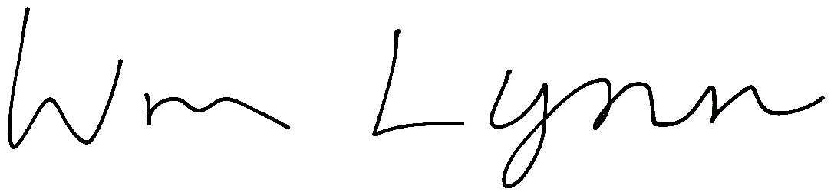
Sincerely,

William S. Lynn, PhD

PAN Works
wlynn@panworks.io
www.panworks.io
508-395-7764

Marsh Institute
Clark University
wlynn@clarku.edu
www.clarku.edu

